 | BERT MASON LIONS YOUNG AMBASSADOR EUROPEAN AWARD, Klagenfurt 2023 | 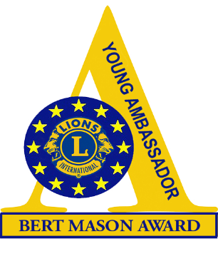

APPLICATION FORM* – to be completed with reference to the Guidance Notes. Please complete in BLACK, either on computer or hand-written.
When complete, one copy should be emailed to your country’s Youth Chairman/Young Ambassador Officer and a second copy to Dieter Van Hoye (European Chairperson) wacouni@live.be until 01 July 2023.

Candidate’s name

Date of birth/Male/Female
Address

Telephone numbers (land line and mobile) and email address
Name of sponsoring Lions Club and District/Multiple District
Name of Lions’ Contact and email address

PARENT/GUARDIAN’S APPROVAL
I certify that my son/daughter may attend the European Final of the Lion Young Ambassador Bert Mason Award in Klagenfurt 2023
Signature of parent/guardian: ______________________________________
The candidate should complete and enclose the following:

- A copy of a letter of support for your entry from an organization with whom you are working in the community.
2. Details of your COMMUNITY INVOLVEMENT -information about all your welfare work.
3. Additional information about your hobbies and interests.
4. Information about how you would spend the bursary should you win the 1.th prize the 3,000-euro bursary (see pages 2 and 3).
5. A photograph of the passport
6. A picture that can be used in a PPT presentation.

Please complete the following pages for Use of the Bursary →→→ → → →

USE OF THE BURSARY - This should give details of how you would spend
the amount of the first prize in case you will win it (3,000 euros).

Please include details of the groups you plan to help and the activities and services that the bursary will help you to provide. The judges of the competition would appreciate as much information as you can give – please continue on additional pages if necessary.

Items to be bought/services provided |  | Estimated Cost – the total should add up to a maximum of 3,000 euros
1.

2.

3.

4.

5.

6.

7.

8.

9.

10.

 | Total Cost

- By signing this document, I agree that photographs of me taken during the different activities of the contest will be used in magazines and on social media, for promoting the competition, recruiting new candidates and follow up of candidates.

- By signing this document, I agree that the information provided by me may be used for promoting the competition, recruiting new candidates and follow-up of candidates.

Signature of Applicant: ………………………………………………………….

For YOUR SPONSORING LIONS CLUB

The Lions Club of ………………………………. understands that it is their responsibility to authorize the use of the Bursary, should this candidate be a winner at the European Final of Lions Young Ambassador Bert Mason Award at Lions Europa Forum Klagenfurt 2023 and signs their agreement to this condition.

Signed: ……………………………………………………….
Club President

Extra information:

The price money will be paid through the account of the sponsoring lions club.

On which account the bursary can be paid:

Name on the account:……………………………………………
IBAN: ……………………………………………………………….
BIC: ………………………………………………………………….

*Privacy statement
The European committee of the Young Ambassador competition will treat all personal information with the utmost care. All received information will be kept for 5 years after the end of the competition.
Publication of photographs taken during the different activities will not be used in magazines and on social media without a signed statement from the candidate giving permission.
The information provided by the candidates may only be used for promoting the competition, recruiting new candidates and follow up of candidates if prior permission has been given.
The candidate can ask for available information by contacting the European Committee of the European Young Ambassador. Changes or complete removal of the data can be requested.
The candidate has the right to prohibit the use of information or photographic material for direct marketing purposes.
None of the information will be made available to third parties. All requests can be sent to: wacouni@live.be

